**Author: Ndubuisi Ezeluomba**

**Onabolu, Aina** (b.1882, Ijebu-Ode, Nigeria – d. 1963)

Born on September 13, 1882, in Ijebu-Ode, Aina Onabolu was the pioneer of Nigerian Modern Art. He occasioned a radical revolution that facilitated the inclusion of arts scholarship into the education curriculum of colonial Nigeria in the 1920s. As a self-taught artist, Onabolu developed his drawing and painting skills through pictures gleaned from textbooks and magazines that were available to him in the early twentieth century when formal art training was not available in Nigeria. Although he became an accomplished artist, Onabolu’s greatest influence was in the teaching of art. After obtaining a diploma in fine arts from European art schools, he returned to Nigeria to promote the fine arts through education and policy reform. As a teacher, Onabolu sought to make his students understand the technical aspects of art. He impressed the sciences of perspective, proportion, colour technology and chiaroscuro upon them, encouraging students to take courses like drawing, basic design and painting, and earning him the title ‘Mr. Perspective’ around the Lagos area, and a reputation that would later earn him the name ‘Father of Modern Nigerian Art’.

Aina Onabolu’s own education in the arts began at the age of twelve, when he taught himself to paint in the European tradition by studying the re-productions of paintings found in widely distributed advertisements and Christian literature in Nigeria at the time of his adolescence. However, in 1920 when an opportunity for formal art studies abroad offered itself, Onabolu did not hesitate to leave the shores of Nigeria for academic training in Europe. He set sail for England and France where he studied drawing, painting and art education at Académie Julian in Paris as well as the St. John Wood School and the Royal Academy of Art in London. He obtained a fine arts diploma and a teaching certificate. Back in Nigeria in 1922, Onabolu put his technical training to use in the production of naturalistic portraits of the influential figures in the Lagos area. While these portraits would come to define his artistic career stylistically, he also introduced modernist ideas to art in Nigeria through these works. Several of Onabolu’s contemporaries in South Africa who sought the same agendas in their creativity included Gerard Sekoto, John K. Mohl and Ernest Mancoba.

Onabolu’s greatest influence however, was not as an artist but as an advocate for arts education in Nigeria. Onabolu had returned to Nigeria from Europe at a time when a report on British colonial education policy recommended the inclusion of native handicrafts in the curriculum. This was the opportunity Onabolu needed to persuade local officials, and begin teaching art part-time at King’s College of Lagos.

Onabolu’s efforts in establishing the foundation of Art Education in the British colony of Nigeria were successful. In 1922, the colonial government authorized Fine Art as a subject in the educational curriculum, and by 1923 Modern art was being taught in the secondary school system. Finally, his artistic activities along with the resolve to include art scholarship into the education curriculum of Nigeria culminated in the birth and subsequent development of Nigerian Modern Art.

Not all of Onabolu’s contemporaries or followers would see eye-to-eye with his vision of an arts program based heavily on Western tradition. Ulli Beier argued that arts education, like all of Nigeria’s education was too foreign-oriented. However, another critical achievement of Onabolu’s, his request for qualified teaching staff to be hired from abroad, resulted in the hiring of an influential force for arts education based on regional traditions. The colonial education department conceded to Onabolu’s request by inviting Kenneth C. Murray, a young British teacher to come and help develop art education in Nigeria. Murray’s appointment would prove to be a turning point in arts education through the promotion of Nigerian arts and crafts in the schools. Though the activities of Murray and Onabolu had different aims, their efforts resulted in numerous new artists and art instructors , and the laying of a foundation for Nigeria’s Modern art movement.

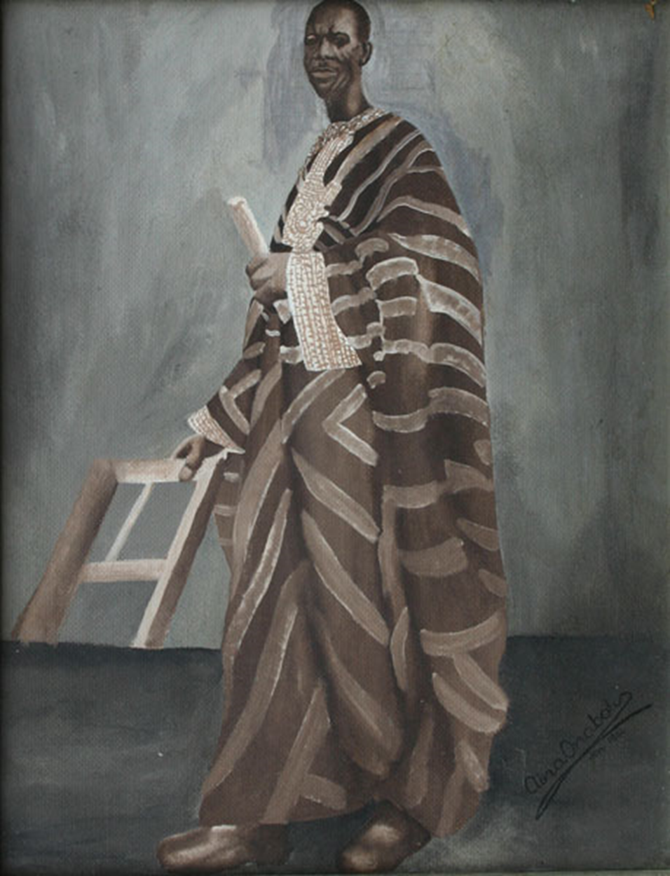

Aina Onabolu, Portrait of a Man, 1955. Watercolour on board. 48.5 x 38.5 cm.

Collection of Omooba Yemisi Adedoyin Shyllon Art Foundation (OYASAF)

<http://www.arthouse-ng.com/L0802/Popups/AINA_ONABOLU.html>

**References and further reading.**

* Olubukola, A. Gbadegasin (2006) The intersection of modern art, anthropology, and international politics in colonial Nigeria, 1910-1914. Emory University. MA dissertation.
* Irivwieri, G. Ogheneruemu (2010) Aina Onabolu and Naturalism in Nigerian Visual Arts in *African Research Review* 4(1) 40-50
* Ikpakronyi, O. Simon. (1999) Aina Onabolu: His Life, His Works and His Contributions to the Developments of Contemporary Nigerian Art, *Onabolu: Pioneer of Modern Art*. Lagos, Nigeria: National Gallery of Art.
* Oguibe, Olu. (2002) Appropriation as Nationalism in Modern African Art. *Third Text,* 16(3) 243-259
* Onabolu, Aina, et al (1999) Aina Onabolu: symbol of the National studios of art. Nigeria: National Gallery of Art.
* Oloidi, Ola (1999) Onabolu, Pioneer of Modern Art in Nigeria: an Introduction. *USO: Nigerian Journal of Art*, 2(1) 1-9.
* _________(1991) Defender of African creativity: Aina Onabolu, pioneer of western art in West Africa. *Africana Research Bulletin.* 17(2) 21-49.
* _________(1986) Growth and development of formal art education. *Transafrican journal of history.* 15(1) 108-126.
* Onuchukwu, Chidum (1994) “Art Education in Nigeria” *Art Education* 54-60